# A.Venkata DineshReddy(RA1911028010098)-CSE(CloudComputing)

# **Sentiment Analysis**

# **Introduction:**

# Sentiment Analysis allows customers to choose the best product by analyzing the mixed reviews and produce the accurate percentages of positive,negative and neutral values by using NLP which is sentimental analysis and using boto3 we are going to access to the services of amazon comprehend which will perform sentiment analysis directly to the input and produce us the required output.

# Sentiment analysis uses NLP to determine whether data is positive, negative or neutral. Sentiment analysis is often performed on textual data to help businesses monitor brand and product sentiment in customer feedback, and understand customer needs.

# Sentiment analysis models focus on polarity (positive, negative, neutral) but also on feelings and emotions (angry, happy, sad, etc), urgency (urgent, not urgent) and even intentions (interested v. not interested).

## STEP:1

Check whether python version,pip3 version and boto3 are available or not,if not so install them to connect python script to amazon comprehend.

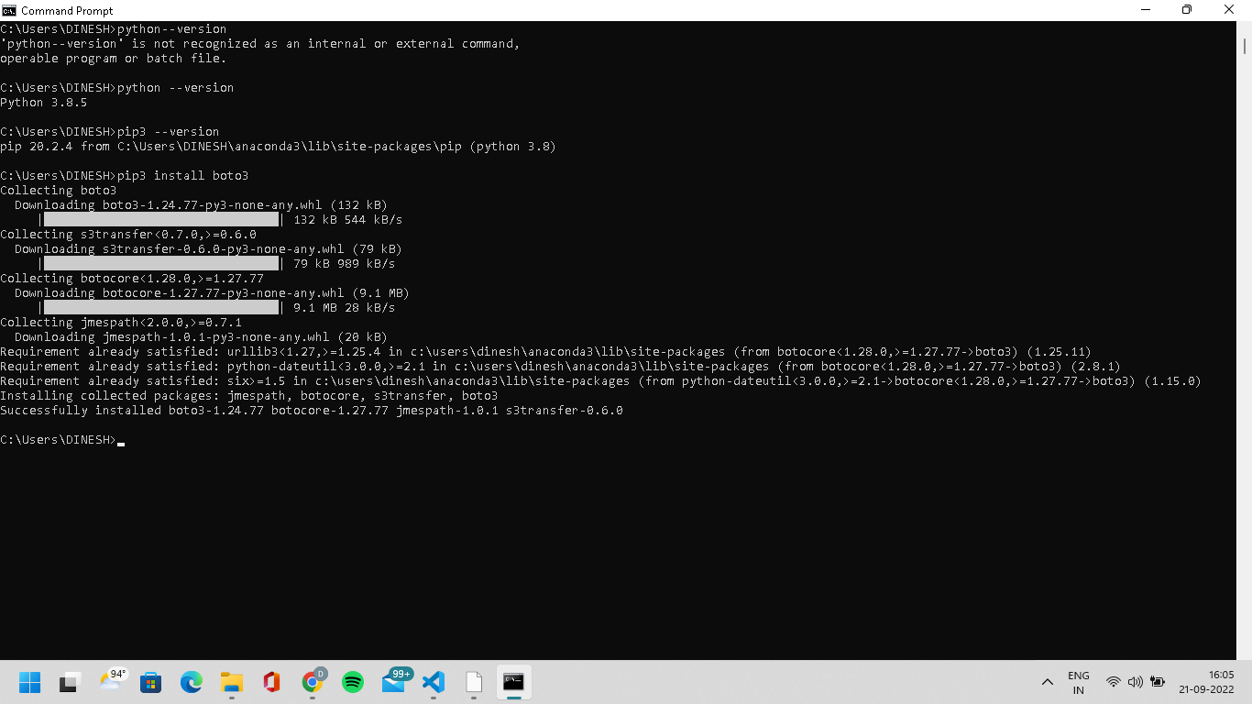

## STEP:2

Then install the awscli using command prompt to connect to the AWS management console.

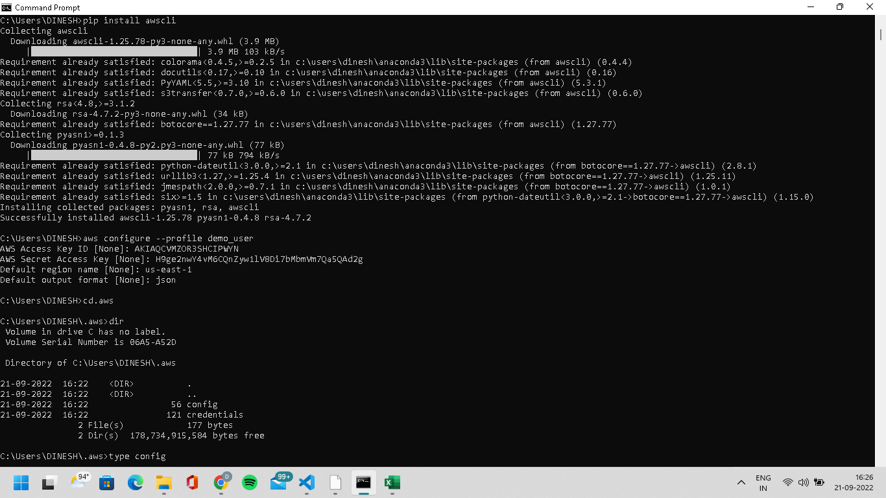

## STEP:3

## Create an AWS account.

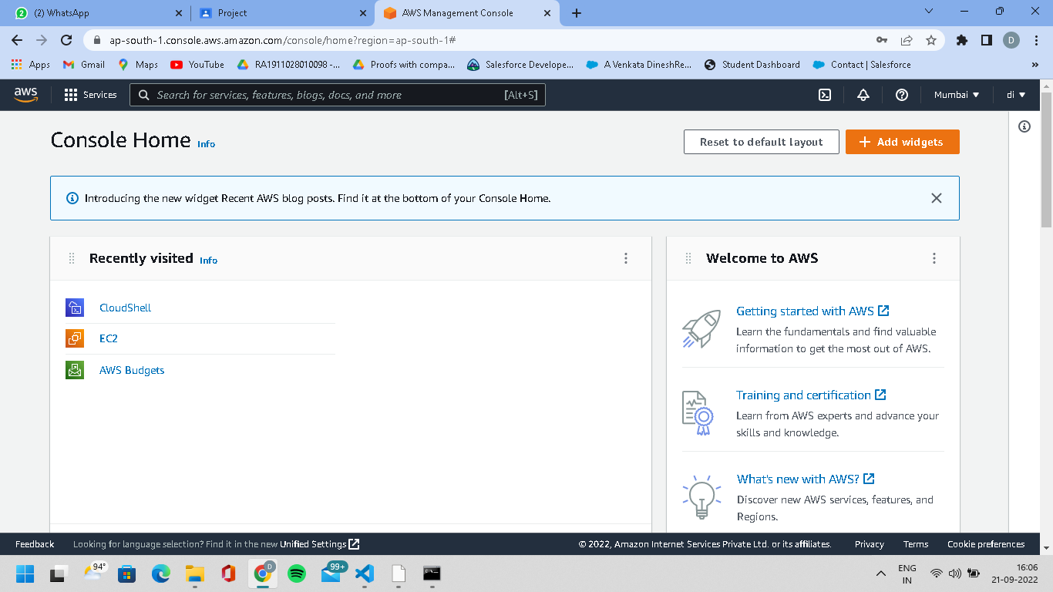

## STEP:4

Then give the requied IAM permissions for which we are accessing ,firstly we have to select users from IAM.

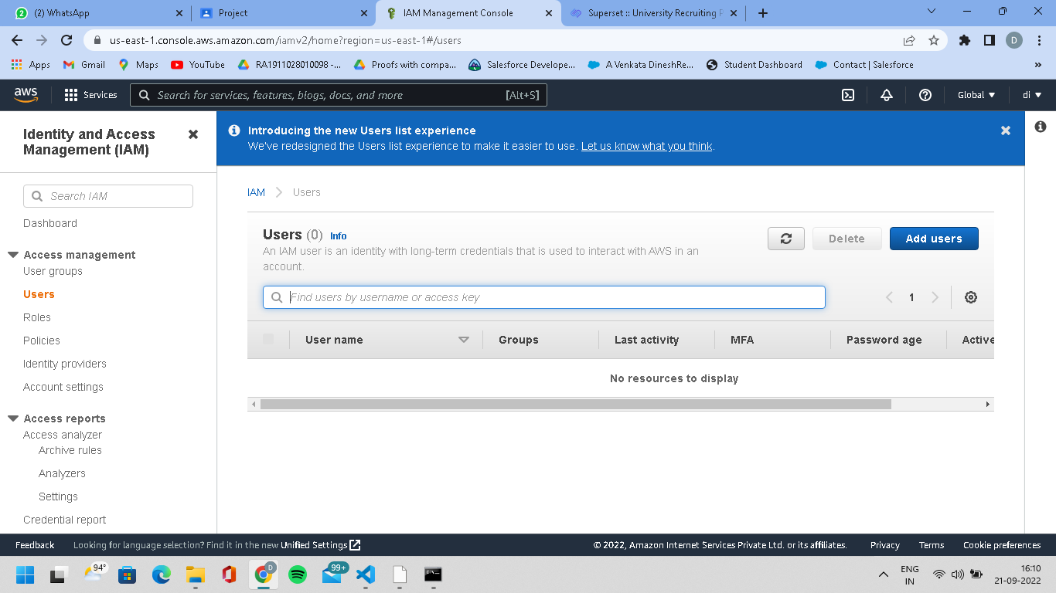

## STEP:5

## Then click on add users and create username(I have created as demo_user)and select the checkbox of required AWS credential type.

## 

## STEP:6

## Then set the required permissions(I have selected administrator access).

## 

## STEP:7

## Then u can review whatever u have given.

## 

## STEP:8

Then click on create user.Here u can download csv file where u can get access key id and secret access key

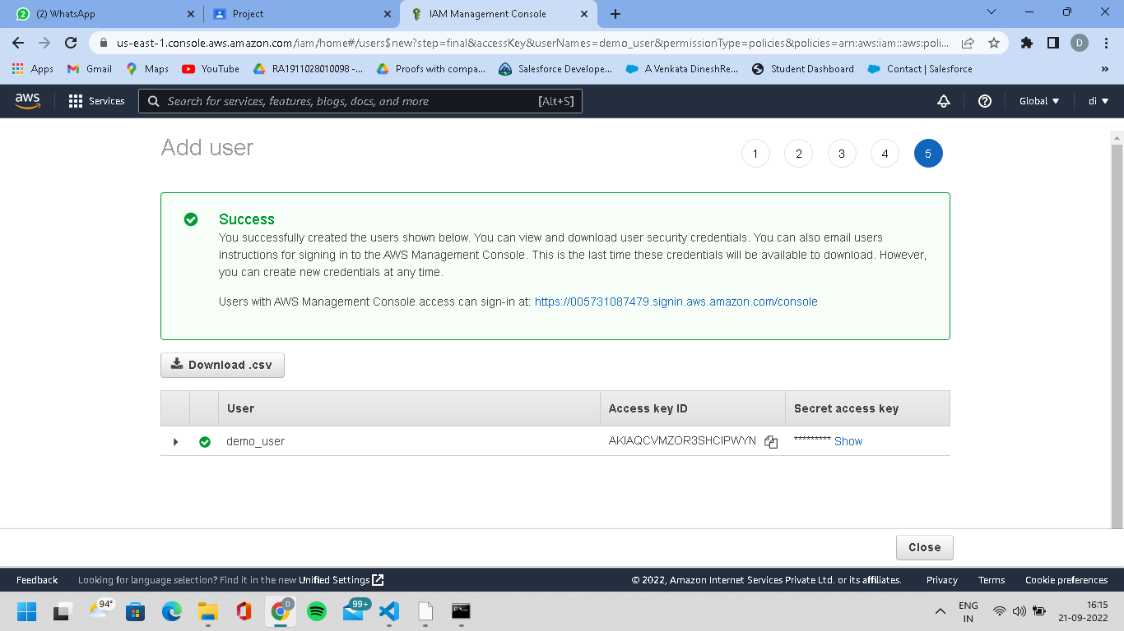

## STEP:9

## Then u can type some commands in command prompt to verify whether the demo_user profile has been created or not.

## 

## STEP:10

## Then I have created some gui using tkinter where we can paste the test and also a button called read is created.

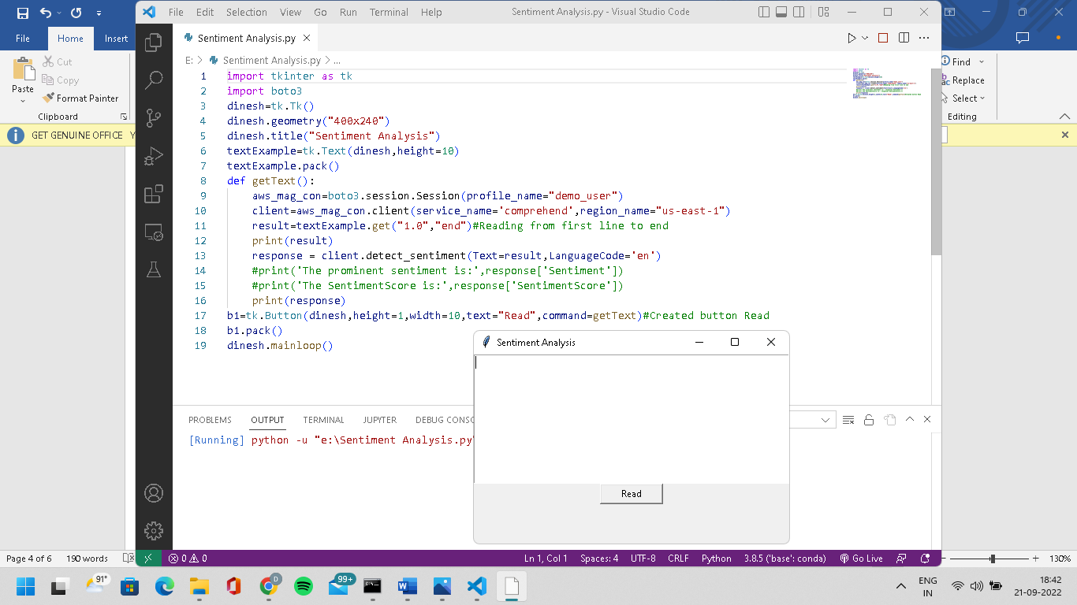

## STEP:11

Then if we write some text and click on read it will detect the semantic analysis through amazon comprehend service and gives us the sentiment score in dictionary format as required result.

## 11.1

## 

## 11.2

## 

## 11.3

## 

## STEP:12

Not only this,with the help of boto3 and using amazon comprehend service we can perform actions like detecting key phrases,detecting syntax etc.

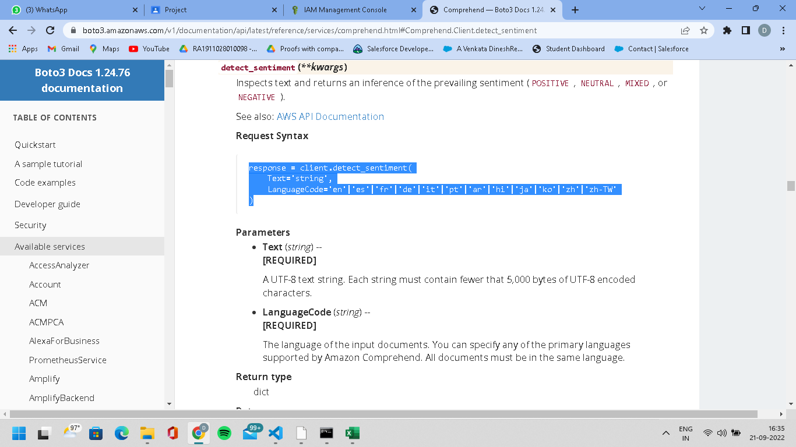

# **Result:** This project helps us to identify the sentimental score of a particular sentence and gives us the feedback of positive,negative and neutral results using amazon comprehend service in AWS.